**Name:** Sania Rashid

**Datasets:**

<https://drive.google.com/file/d/1_9oh2OcIm_Lamzo7ENjqlLJEzVfAN1IB/view?usp=sharing>

<https://drive.google.com/file/d/1_9oh2OcIm_Lamzo7ENjqlLJEzVfAN1IB/view?usp=sharing>

**GitHub Repo:**

**Visualisation 1:** Line plot

Change in Number of Internet Users From 1990 to 2015

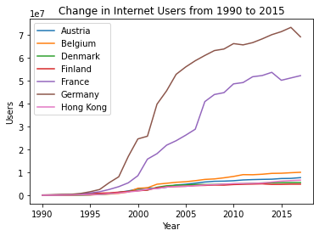

Line graphs are best in describing the relationship of two entities over time. Using line graphs, we can display a trend in and the nature of that trend in the data. It is also helpful to show the variation in data over time.

The Internet has changed the way we learn, live, and communicate. It has connected the whole world. To analyse the change in the number of users on the Internet, I have got the data (from the Internet) about some countries and their number of Internet users from year 1990 to year 2015.

In the preceding image, we can conclude a roughly linear trend in some countries. Some countries also show a constant trend against increase in internet users per year, but we cannot underestimate the Internet using this constant trend because of the less population of those countries.

**Visualisation 2:** Bar plot

GDP of a Country from 1960 to 2021

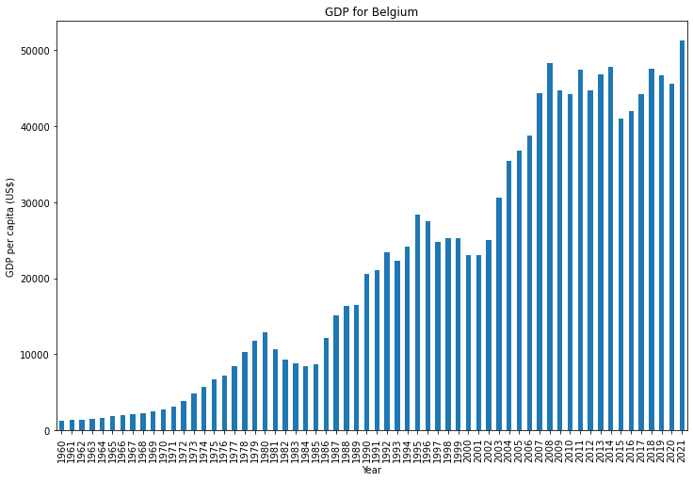

Bar plots are good to compare and summarise the data in different categories. They are particularly useful for presenting categorical data, which is data that can be divided into distinct categories or groups.

GDP performs a crucial role in the development of a country. I found a dataset for GDP of some countries from 1960 to 2021. I have created a bar plot about GDP for Belgium from 1960 to 2021.

In the last graph, we can conclude that there were a lot of ups and downs in the development of Belgium but in the year 2021, Belgium performed well, and its GDP is on the top of other years.

**Visualisation 3:** Pie Plot

Internet Users Distribution in Different Countries:

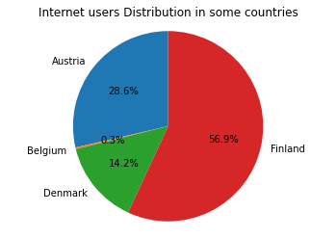

If we want to display the distribution of some data, then a pie plot is the best choice. This graph is helpful to display data as a proportion of whole.

I have created a pie graph to display the contribution of Internet users in some countries. If we assume that there are only four countries in the world, then we can conclude that there are more than 50% of all internet users in Finland.